**DAILY ONLINE ACTIVITIES SUMMARY**

|  |  |  |  |  |  |  |  |  |
| --- | --- | --- | --- | --- | --- | --- | --- | --- |
| **Date:** | **4/6/2020** | | | | | **Name:** | **Banish M G** | |
| **Sem & Sec** | **8th Sem** | | | | | **USN:** | **4AL16CS020** | |
| **Online Test Summary** | | | | | | | | |
| **Subject** | | **SMS** | | | | | | |
| **Max. Marks** | | **60** | | **Score** | | | **60** | |
| **Certification Course Summary** | | | | | | | | |
| **Course** | **Python for data science** | | | | | | | |
| **Certificate Provider** | | | **udemy** | | **Duration** | | | **23 hrs** |
| **Coding Challenges** | | | | | | | | |
| **Problem Statement:**  1. Python Program to Find the Size (Resolution) of a Image | | | | | | | | |
| **Status:COMPLETED** | | | | | | | | |
| **Uploaded the report in Github** | | | | | **yes** | | | |
| **If yes Repository name** | | | | | B**anish_MG** | | | |
| **Uploaded the report in slack** | | | | | **yes** | | | |

Online Test Details: (Attach the snapshot and briefly write the report for the same)

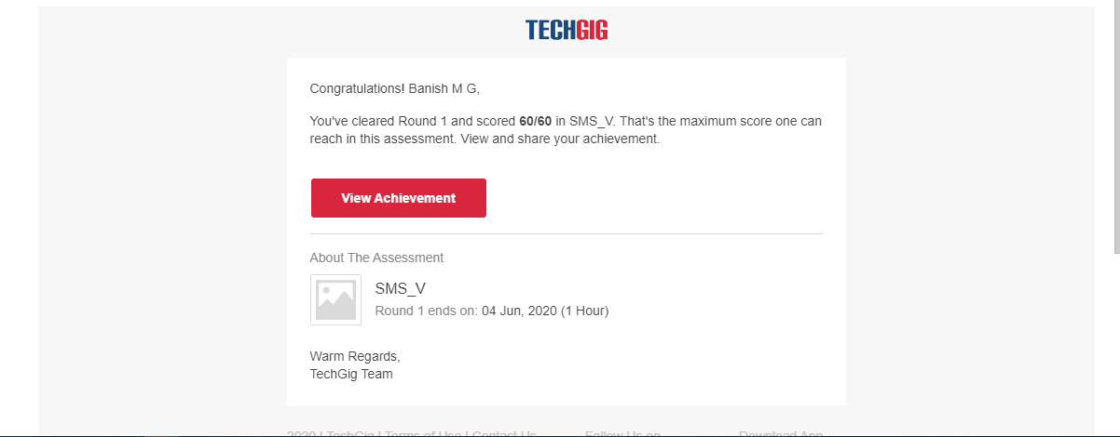

Certification Course Details: (Attach the snapshot and briefly write the report for the same)

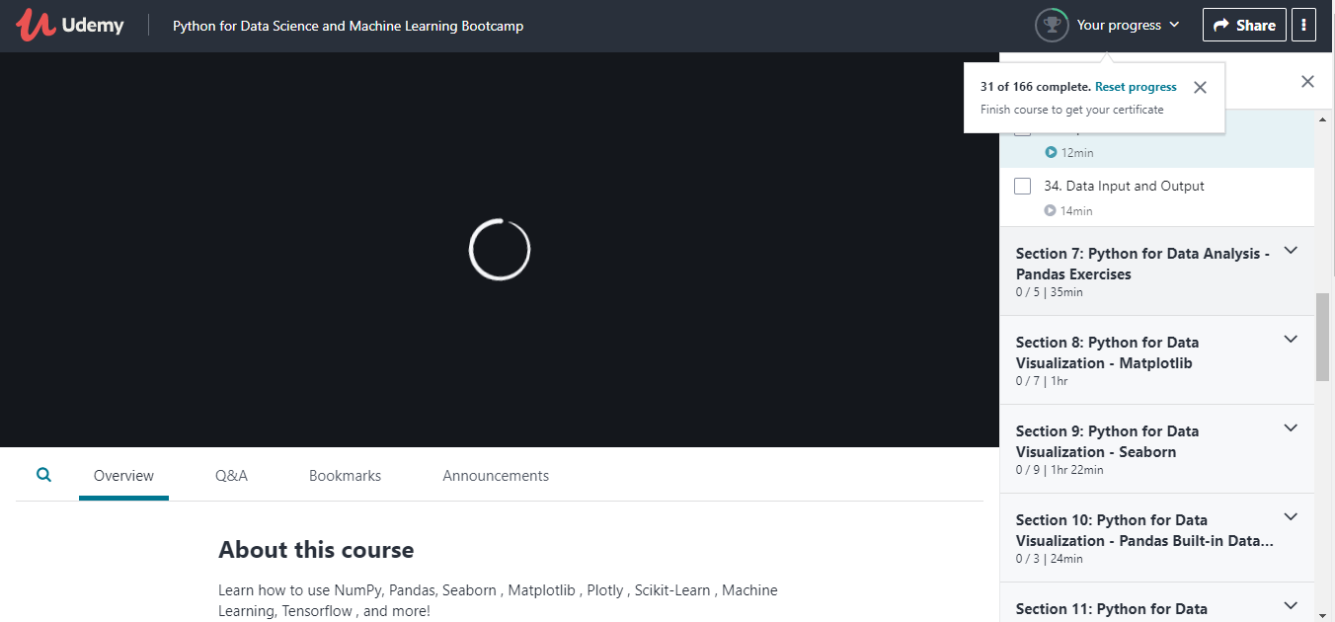

Coding Challenges Details: (Attach the snapshot and briefly write the report for the same)

Problem Statement:

Python Program to Find the Size (Resolution) of a Image

defjpeg_res(filename):

#openimageforreadinginbinarymode withopen(filename,'rb')asimg_file:

#heightofimage(in2bytes)isat164thposition img_file.seek(163)

#readthe2bytes

a=img_file.read(2)

#calculateheight

height=(a[0]<<8)+a[1]

#next2bytesiswidth

a=img_file.read(2)

#calculatewidth

width=(a[0]<<8)+a[1]

print("Theresolutionoftheimageis",width,"x",height) jpeg_res("img1.jpg")